**When implementing Template Method, if you want an operation to perform variable number of steps, you can use as method argument an Iterator of ___?**

1. Composite
2. **Command**
3. Singleton
4. Visitor

**Can you recognize what Design Pattern has been used in the following real world example?**

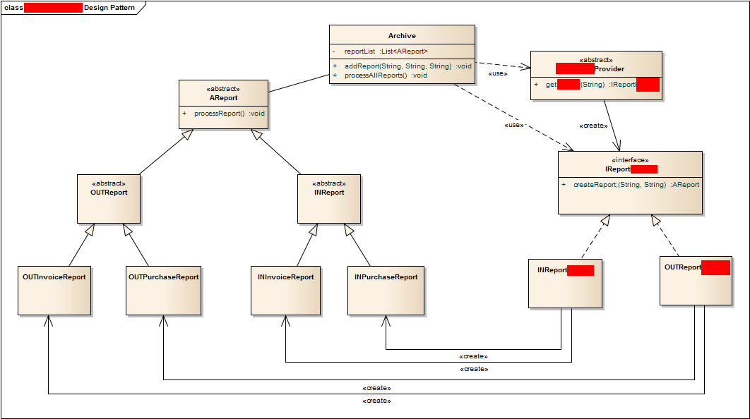

1. **Abstract Factory**
2. Visitor
3. Strategy
4. Composite

**Can you implement Template Method in Java 7 using an Interface and its implementations?**

1. Yes
2. **No**

**Which operation must be shared between Composite, Component and Leaf?**

1. add
2. remove
3. getChild
4. **none of the above**

**Select two OOP features used to implement Template method:**

1. Inheritance and Overloading
2. **Polymorphism and Inheritence**
3. Composition and Polymorphism
4. Overloading and Composition

**What Design Pattern is used to create an interchangeable family of algorithms from which the required process is chosen at run-time?**

1. Composite
2. Template Method
3. **Strategy**
4. Visitor